What is LoRaWAN Specification?

The LoRaWAN® specification is a Low Power, Wide Area (LPWA) networking protocol designed to wirelessly connect battery operated ‘things’ to the internet in regional, national or global networks, and targets key Internet of Things (IoT) requirements such as bi-directional communication, end-to-end security, mobility and localization services.

**Topology**

LoRaWAN® network architecture is deployed in a star-of-stars topology in which gateways relay messages between end-devices and a central network server. The gateways are connected to the network server via standard IP connections and act as a transparent bridge, simply converting RF packets to IP packets and vice versa. The wireless communication takes advantage of the Long Range characteristics of the LoRaÒ physical layer, allowing a single-hop link between the end-device and one or many gateways. All modes are capable of bi-directional communication, and there is support for multicast addressing groups to make efficient use of spectrum during tasks such as Firmware Over-The-Air (FOTA) upgrades or other mass distribution messages.

**Classes**

**Class A – Lowest power, bi-directional end-devices:**

The default class which must be supported by all LoRaWAN end-devices, class A communication is always initiated by the end-device and is fully asynchronous. Each uplink transmission can be sent at any time and is followed by two short downlink windows, giving the opportunity for bi-directional communication, or network control commands if needed. This is an ALOHA type of protocol.  
The end-device is able to enter low-power sleep mode for as long as defined by its own application: there is no network requirement for periodic wake-ups. This makes class A the lowest power operating mode, while still allowing uplink communication at any time.  
Because downlink communication must always follow an uplink transmission with a schedule defined by the end-device application, downlink communication must be buffered at the network server until the next uplink event.

**Class B – Bi-directional end-devices with deterministic downlink latency:**

In addition to the class A initiated receive windows, class B devices are synchronized to the network using periodic beacons, and open downlink ‘ping slots’ at scheduled times. This provides the network the ability to send downlink communications with a deterministic latency, but at the expense of some additional power consumption in the end-device. The latency is programmable up to 128 seconds to suit different applications, and the additional power consumption is low enough to still be valid for battery powered applications.

**Class C – Lowest latency, bi-directional end-devices:**

In addition to the class A structure of uplink followed by two downlink windows, class C further reduces latency on the downlink by keeping the receiver of the end-device open at all times that the device is not transmitting (half duplex). Based on this, the network server can initiate a downlink transmission at any time on the assumption that the end-device receiver is open, so no latency. The compromise is the power drain of the receiver (up to ~50mW) and so class C is suitable for applications where continuous power is available.  
For battery powered devices, temporary mode switching between classes A & C is possible, and is useful for intermittent tasks such as firmware over-the-air updates.

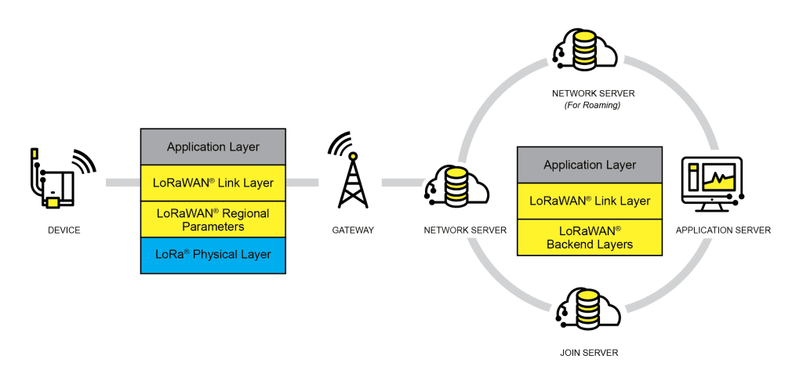

Fig1. LoRaWAN® Network Architecture

In addition to frequency hopping, all communication packets between end-devices and gateways also include a variable ‘Data rate’ (DR) setting. The selection of the DR allows a dynamic trade-off between communication range and message duration. Also, due to the spread spectrum technology, communications with different DRs do not interfere with each other and create a set of virtual ‘code’ channels increasing the capacity of the gateway. To maximize both battery life of the end-devices and overall network capacity, the LoRaWAN® network server manages the DR setting and RF output power for each end-device individually by means of an Adaptive Data Rate (ADR) scheme.

LoRaWAN® baud rates range from 0.3 kbps to 50 kbps.

Security is a primary concern for any mass IoT deployment and the LoRaWAN® specification defines two layers of cryptography:

* A unique 128-bit Network Session Key shared between the end-device and network server
* A unique 128-bit Application Session Key (AppSKey) shared end-to-end at the application level

AES algorithms are used to provide authentication and integrity of packets to the network server and end-to-end encryption to the application server. By providing these two levels, it becomes possible to implement ‘multi-tenant’ shared networks without the network operator having visibility of the users payload data.

The keys can be Activated By Personalisation (ABP) on the production line or during commissioning, or can be Over-The-Air Activated (OTAA) in the field. OTAA allows devices to be re-keyed if necessary.

Read our Security Whitepaper [here](https://lora-alliance.org/resource_hub/lorawan-security-whitepaper/)

Read our Security FAQs here [/resource-hub/lorawan-security-faq](https://lora-alliance.org/resource-hub/lorawan-security-faq)

The specification defines the device-to-infrastructure (LoRa®) physical layer parameters & (LoRaWAN®) protocol and so provides seamless interoperability between manufacturers, as demonstrated via the device certification program.  
While the specification defines the technical implementation, it does not define any commercial model or type of deployment (public, shared, private, enterprise) and so offers the industry the freedom to innovate and differentiate how it is used.  
The LoRaWAN® specification is developed and maintained by the LoRa Alliance®: an open association of collaborating members.